Linkovi: [ESP32-S2-Saola-1_V1.2_Dimensions.pdf](https://dl.espressif.com/dl/schematics/ESP32-S2-Saola-1_V1.2_Dimensions.pdf)

[ESP32-S2-SAOLA-1_V1.1_schematics.pdf](https://dl.espressif.com/dl/schematics/ESP32-S2-SAOLA-1_V1.1_schematics.pdf)

[ADS1298 datasheet](https://www.ti.com/lit/ds/symlink/ads1298.pdf?ts=1616376349539&ref_url=https%253A%252F%252Fwww.ti.com%252Fproduct%252FADS1298)

[ADS1298 Performance Demonstration Kit](https://www.ti.com/lit/ug/sbau171d/sbau171d.pdf?ts=1616394702842&ref_url=https%253A%252F%252Fwww.ti.com%252Ftool%252FADS1298ECGFE-PDK)

# **Input filtar**

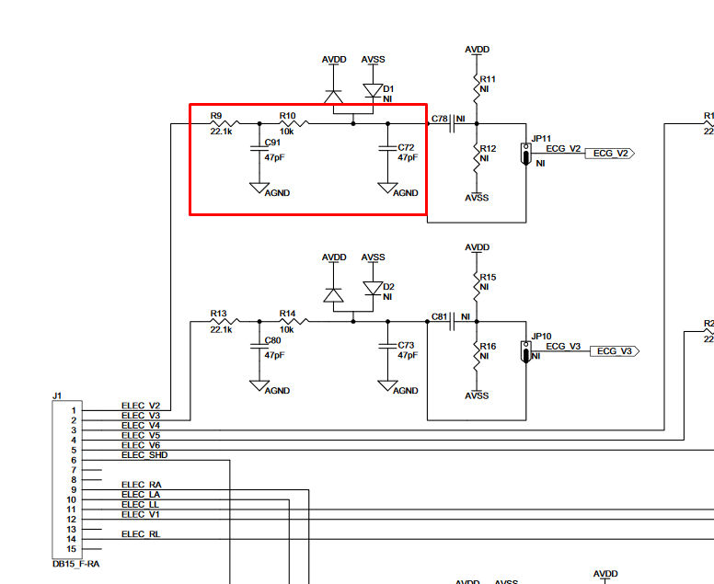

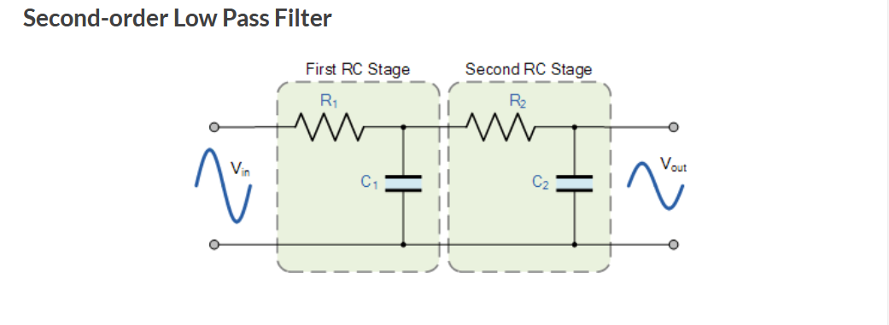

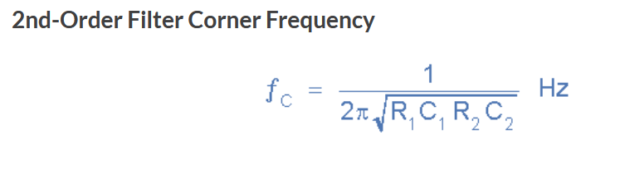

S ovim vrijednostima ta frekvencija bi iznosila f= 227 785 Hz ?

Diode na ulazu – zaštitne diode koje na evaluation boardu nisu niti montirane – vjerojatno nisu potrebne.

# **Multiple-Device Configuration**

Stranica 57

Cascade Configuration

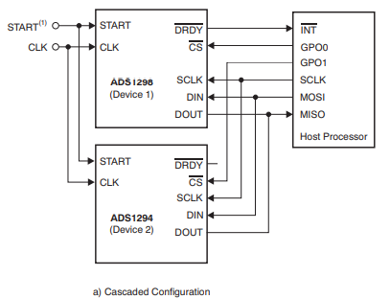

Signal/pins needed

|  |
| --- |
| START |
| CLK |
| /DRDY |
| /CS |
| SCLK |
| DIN |
| DOUT |

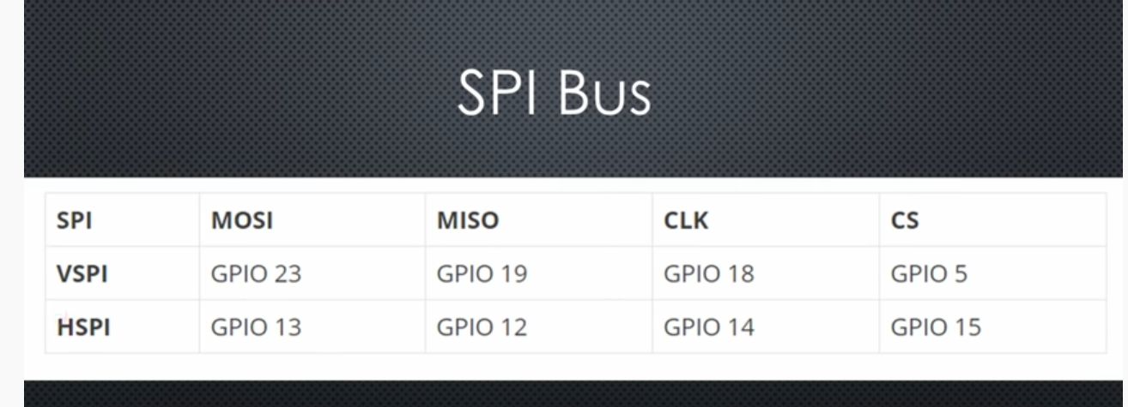

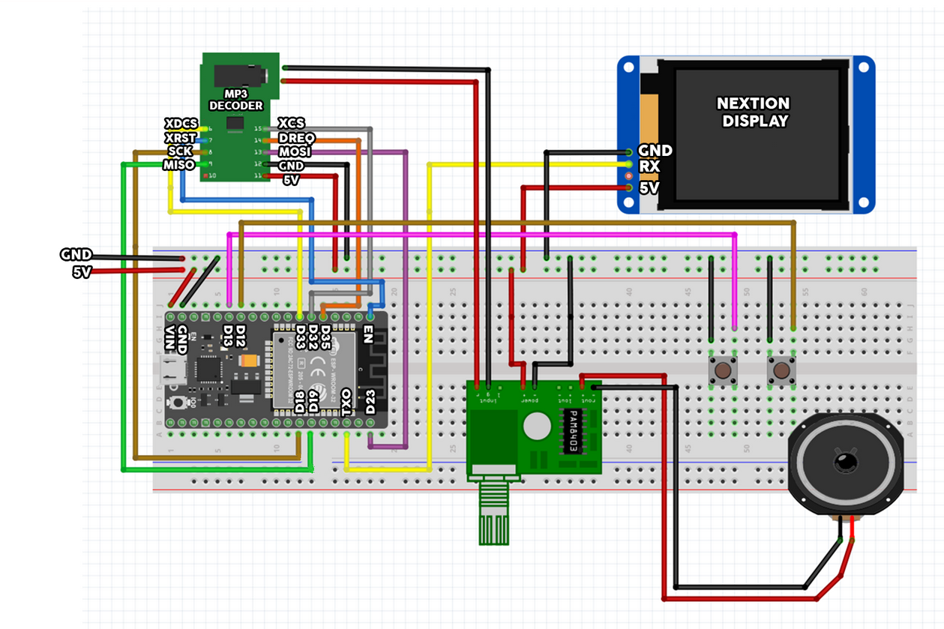

## Power supplies

**ESP32s2**

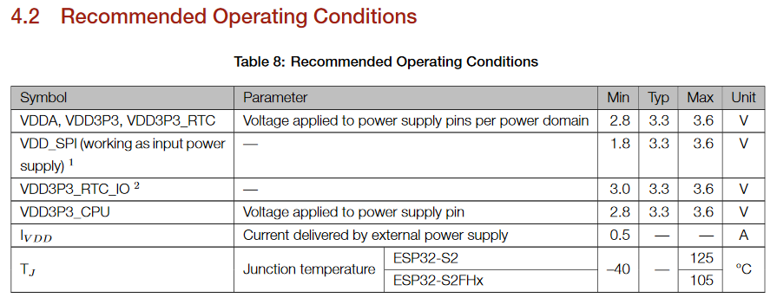

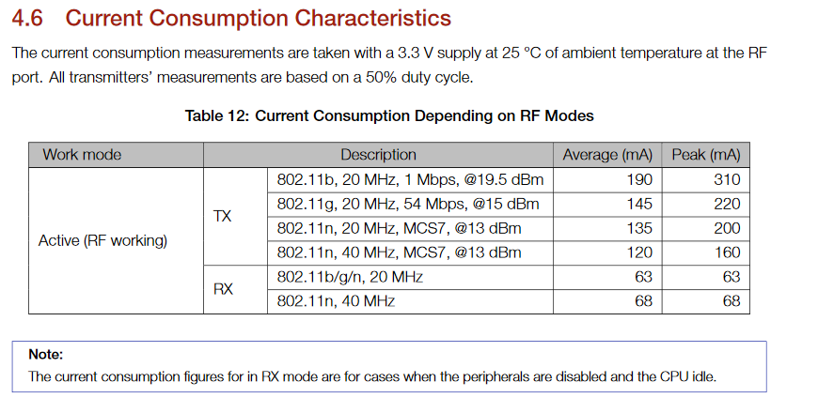

**ADS1298**

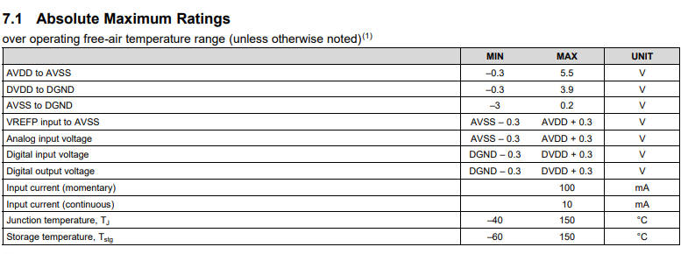

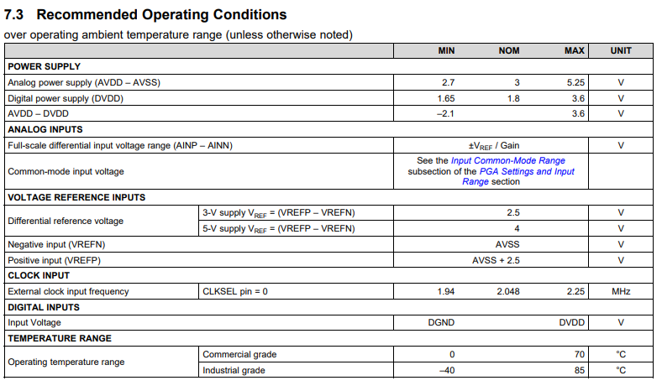

Stranica 97

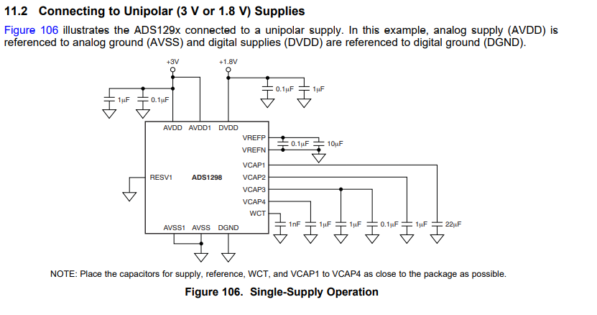

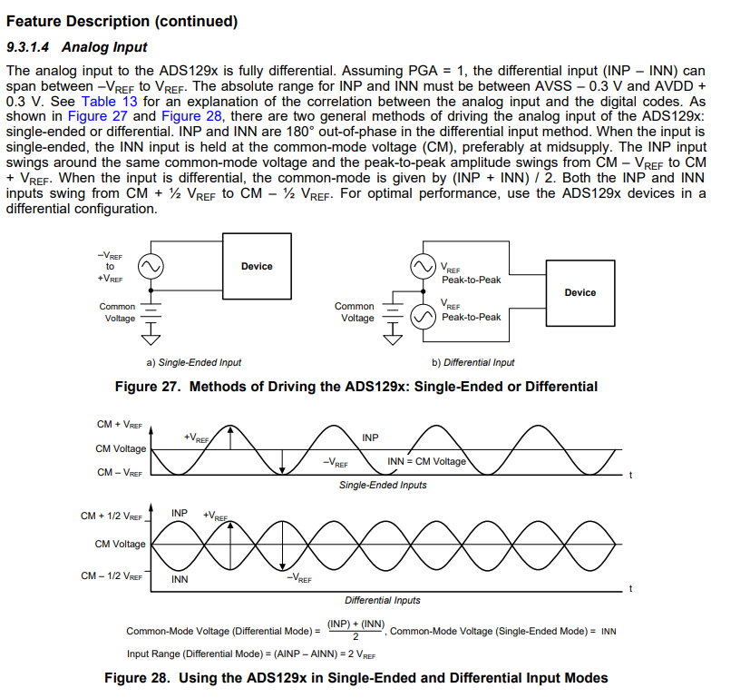

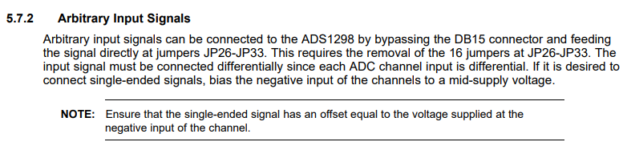

## **Reference voltage**

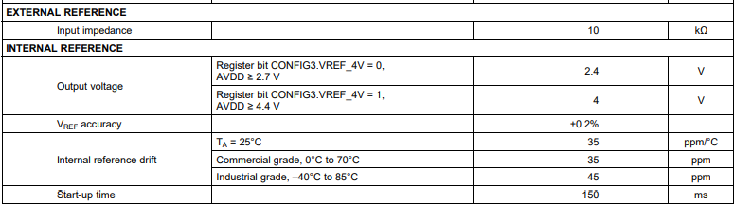

Str 33.

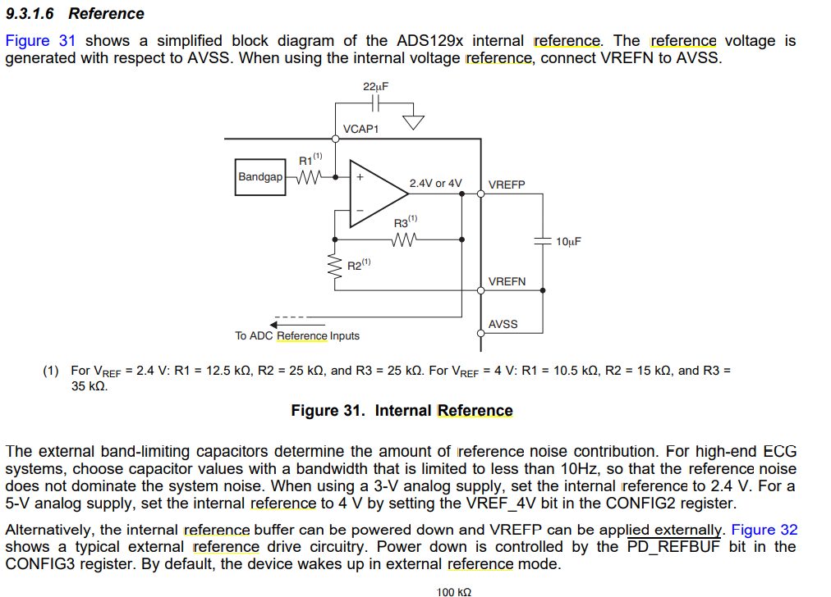

Vanjski clck

Mislim da nema smisla – ista frekv kao i unutarnji. CLKSEL pritegnuti na masu

# Pinovi

|  |  |  |
| --- | --- | --- |
| **Pin** | **Ime pina** | **komentar** |
| 1-16 | IN1P,IN1N – IN8P,IN8N | Pozitivni su spojeni na elektrode a negativni na referentnu elektrodu |
| 17 | TESTP_PACE_OUT1(1) | Ovi pinovi imaju više funkcija, mogu se koristiti kao izlazni pinovi za testne signale koje generira sami chip prilikom power – up. (vidi str. 28.) |
| 18 | TESTN_PACE_OUT2(1) |
| 19,21,22,  56,59 | AVDD | Analogno napajanje (3V) |
| 20,23,32,  53,57,58 | AVSS | Analogni ground |
| 24 | VREFP | Pozitivni pin za referencu – koristim unutarnji ref (str 33) |
| 25 | VREFN | Negativni pin reference |
| 26,28,30  55 | VCAP1 – VCAP4 | Spojeni prema shemi za analogni power supply |
| 27,29 | NC | NC |
| 31 | RESV1 | Spojen na DGND |
| 33,49,51 | DGND | Digitalni ground |
| 34 | DIN |  |
| 35 | /PWDN | Power-down pin; active low |
| 36 | /RESET | System-reset pin; active low |
| 37 | CLK | ? |
| 38 | START |  |
| 39 | /CS | Aktivan low, spojeno kao na str 57. |
| 40 | SCLK | ? |
| 41 | DAISY_IN | Spojen na DGND |
| 42,44,45,  46 | GPIO1 – GPIO4 | NC |
| 47 | /DRDY |  |
| 48,50 | DVDD | Digitalno napajanje, 1V8 |
| 60 | RLDREF |  |
| 61 | RLDINV |  |
| 62 | RLDIN |  |
| 63 | RLDOUT |  |
| 64 | WCT |  |